Supplementary material file 7: Function analysis on candidate mutations.
Evolutionary conservation and structure of wild-type and mutant-type created by SWISS-MODEL:
Autosomal Recessive（8/12）
NT-41 OTOF
c.145C>T, p.R49W

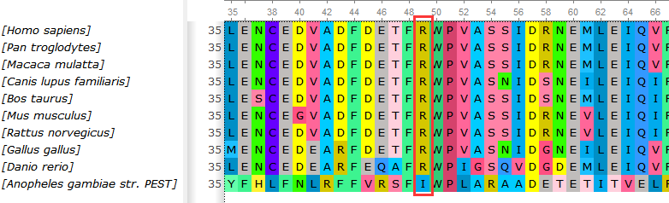
b
a
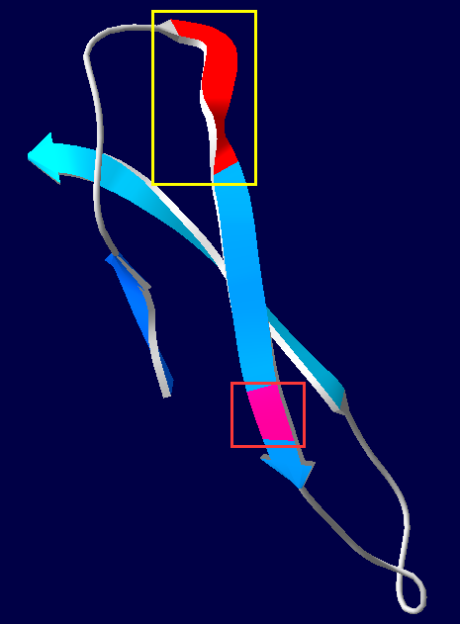
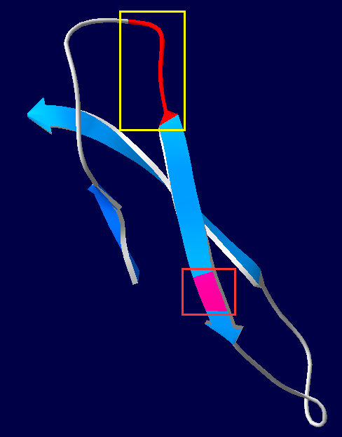

Wild（a），Mutation p.R49W（b）: A hydrogen bond between 34 and 36 was broken and two hydrogen bonds were formed among 41 and 43, 43 and 44 after the 49 Trp mutation.

NT-41 OTOF

c.1364A>T, p.Y455F

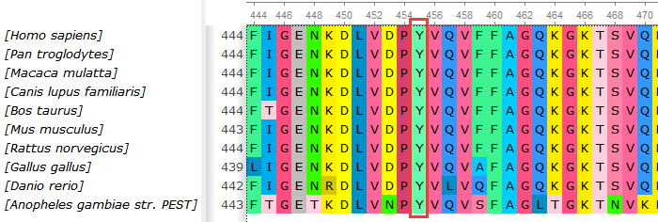

b
a
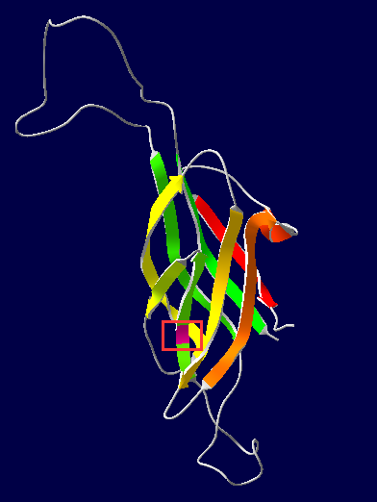
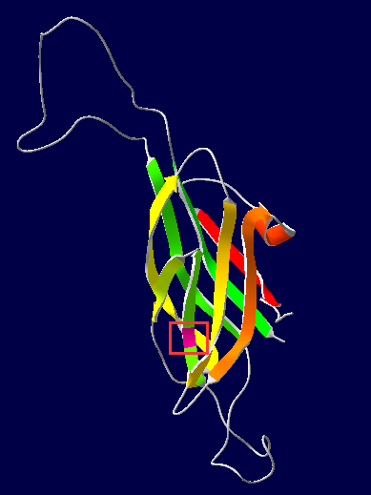

No other structural changes were found for p.Y455F mutation.

NT-44 CDH23 c.9469_9470insGT, p.E3158Vfs*58

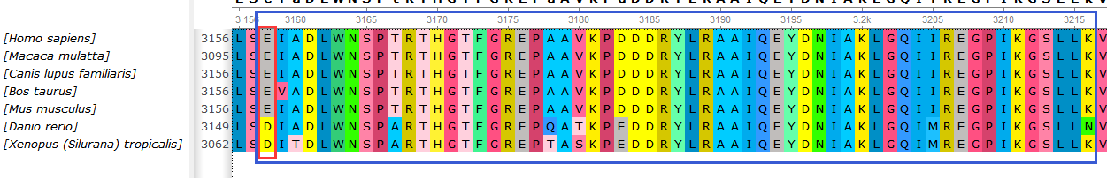
There is no protein structural homology-model for p.E3158Vfs*58.

NT-45 PCDH15
c.4310C>T, p.P1437L

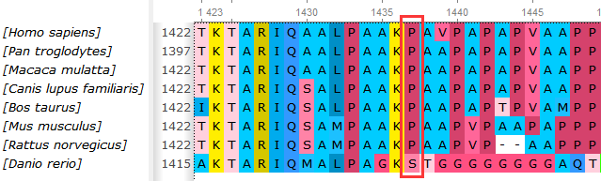

There is no protein structural homology-model for p.P1437L.

Mutation (p.1752_1760delPISPPSPPP)
There is no protein structural homology-model for p.1752_1760delPISPPSPPP.

NT-46 ADGRV1

c.11411G>A, p.R3804Q

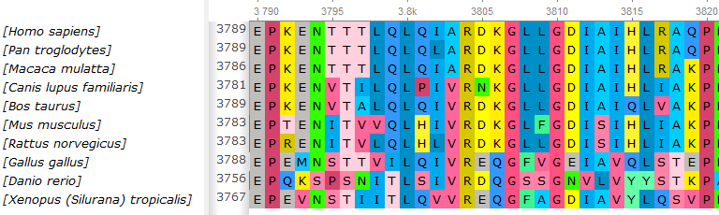

There is no protein structural homology-model for p.R3804Q.

NT-47 PDZD7
c.490C>T, p.R164W

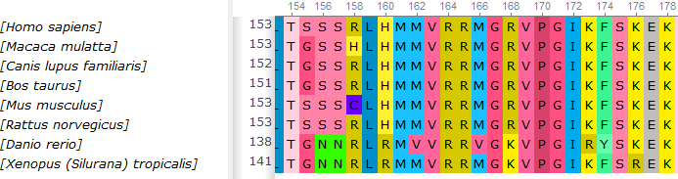
a
b
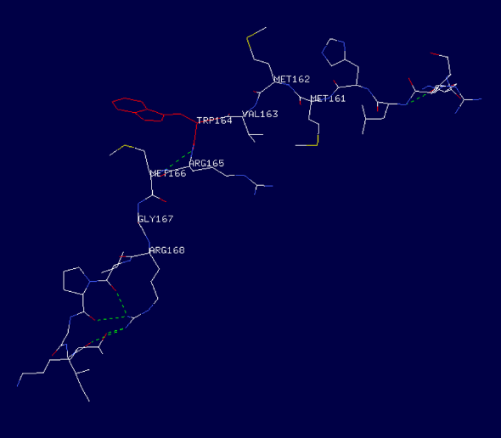
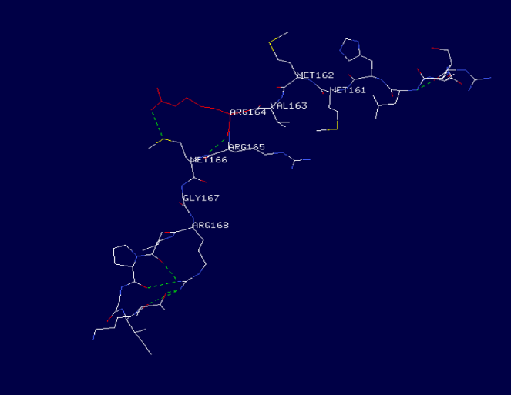

Wild（a），Mutation p.R164W（b）: A hydrogen bond between 164 and 166 were broken after the 164 Trp mutation.

Mutation(c.1574_1597delACCAGGAGAGGGGCCGGGCCCTGC, p.525_533delDQERGRALLinsV)
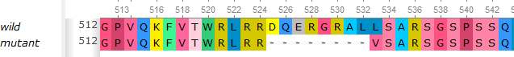

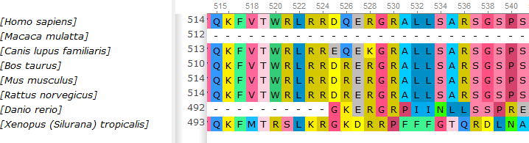

There is no protein structural homology-model for p.525_533delDQERGRALLinsV.

NT-48 KARS
c.685T>C, p.Y229H

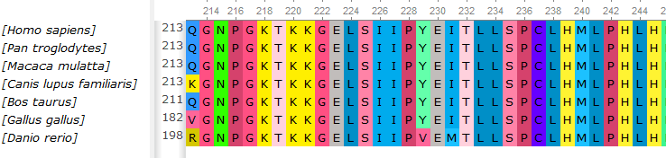
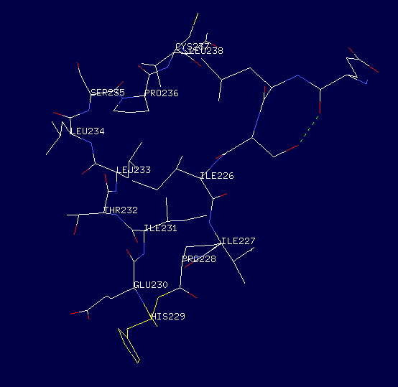
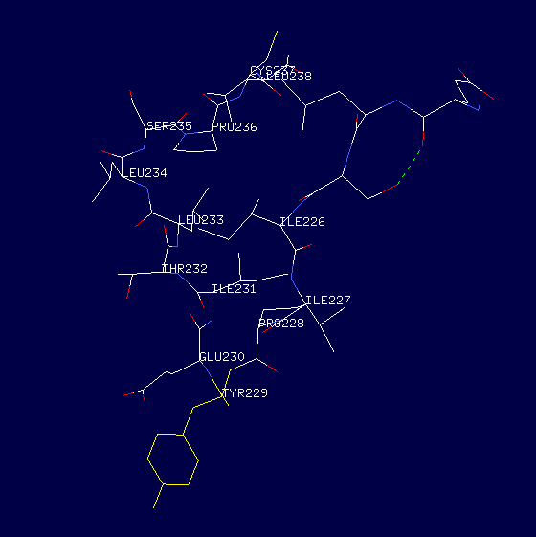
b
a

Wild（a），Mutation p.Y229H（b）: Nothing else changed expect the change p.Y229H.
c.403G>A, p.D135N

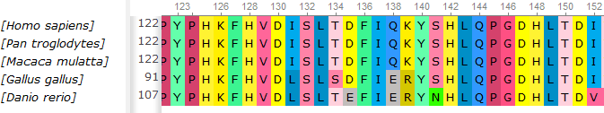
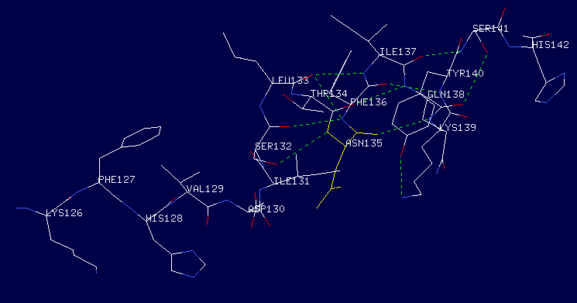
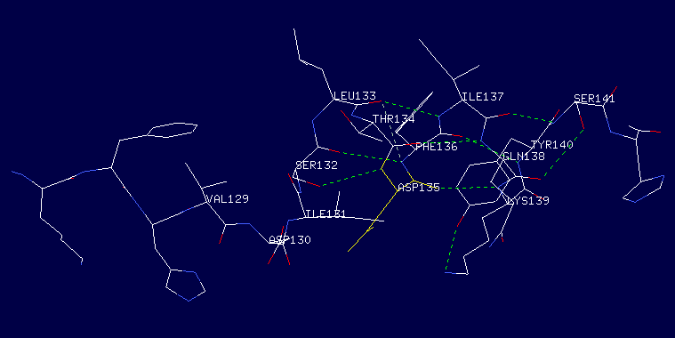
b
a

Wild（a），Mutation p.D135N（b）: Nothing else changed expect the change p.D135N.

NT-51 OTOG
c.433G>A, p.G145S

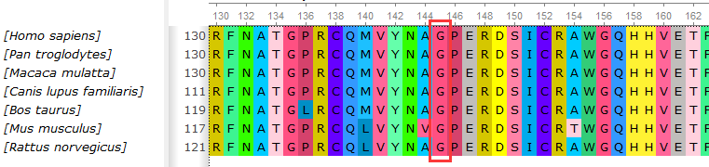
a
b
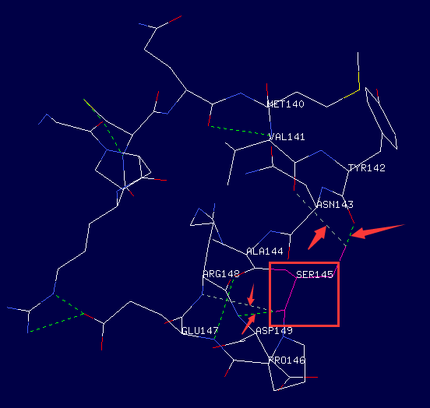
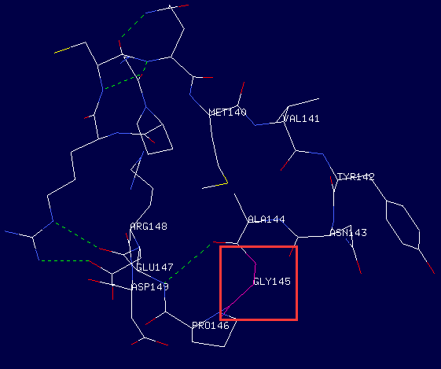

Wild（a），Mutation p.G145S（b）: Four hydrogen bonds were formed among 145 and 141, 142,148,149, respectively after the mutation.

NT-52 GRXCR2, p.K22R
c.65A>G, p.K22R

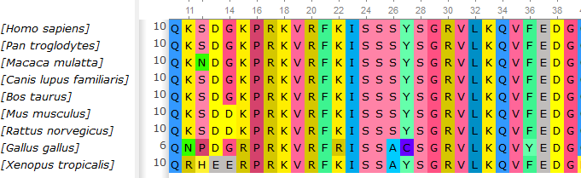

There is no protein structural homology-model for p.K22R.

Autosomal Dominant（2/12）
NT-49 MYO6, p.T197I
c.590C> T, p.T197I

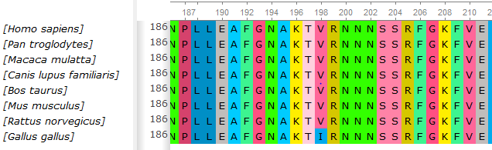

a
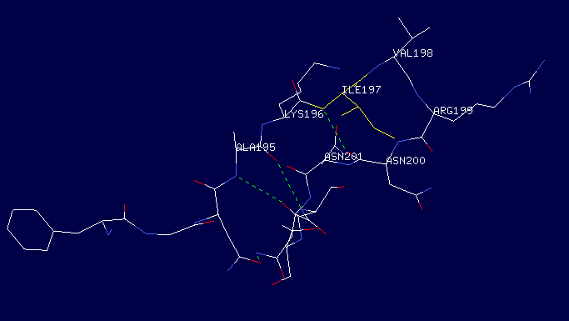
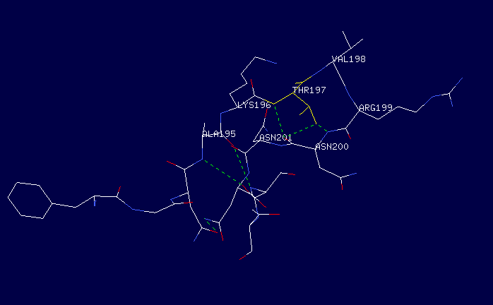
b

Wild（a），Mutation p.T197I（b）: Two hydrogen bonds between 197 and 200 disappear after the p.T197I mutation.

NT-50 GRHL2, p.R426X

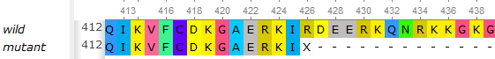
b
a
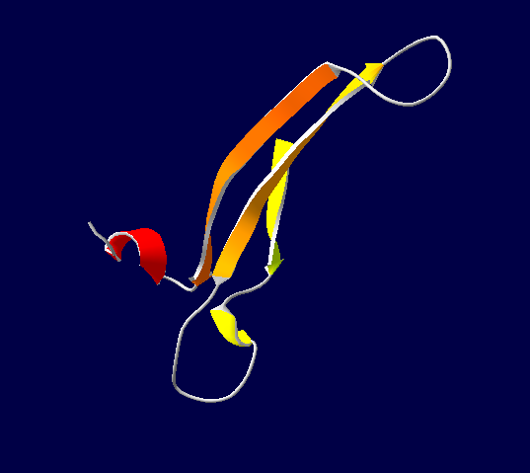
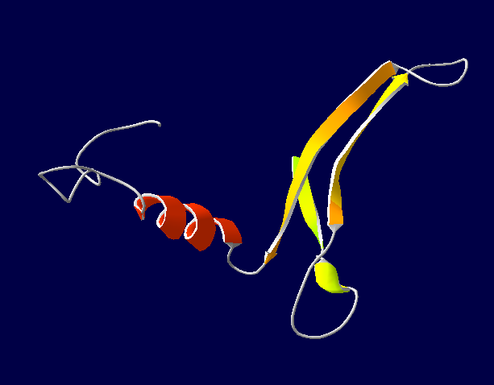

Wild（a），Mutation p.R426X（b）: The missing part is shown in the red box after the p.C233X mutation.
X-linked Recessive（2/12）

NT-42 POU3F4, p.C233X
c.699C>A, p.C233X

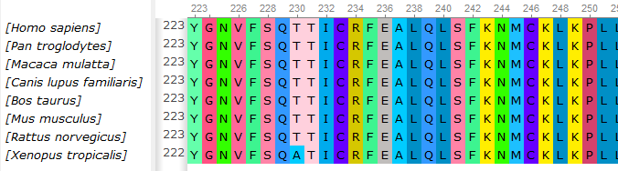

b
a
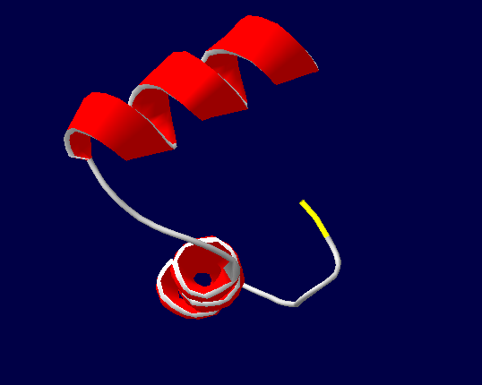
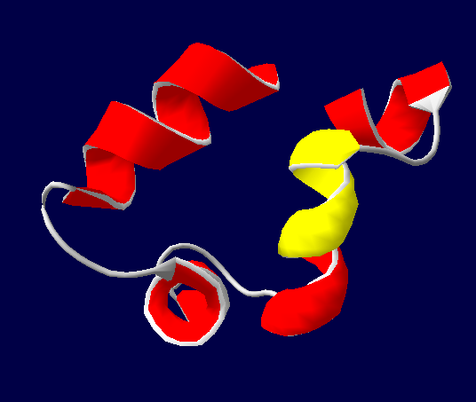

Wild（a），Mutation p.C233X（b）: The missing part is shown in the red box after the p.C233X mutation.

NT-43 POU3F4, p.V321G
c.962T>G, p.V321G

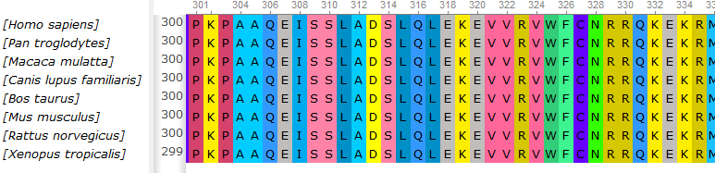

b
a
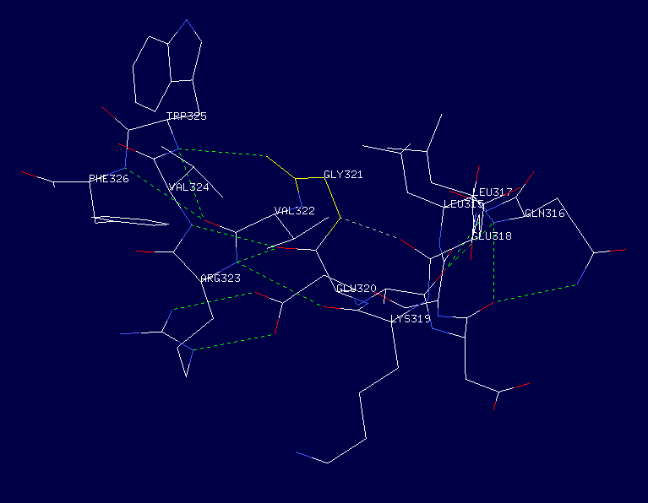
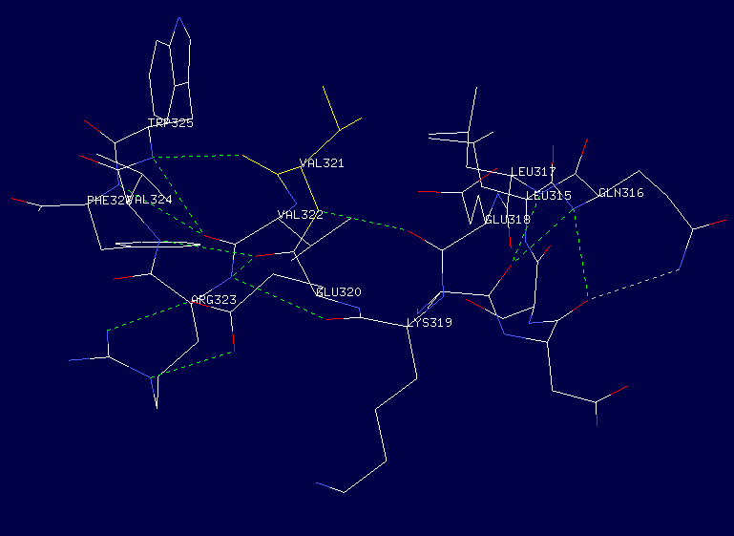

Wild（a），Mutation p.V321G（b）: Nothing else changed expect the red box is the changed area.

